List of Tables

Table 1: Effects of sentinel presence and generalized environment on the proportion of time allocated to each behaviour 10

Table 2: Results of the linear mixed models fit to the mean bout duration 12

Table 3: Result of the linear mixed model fit to forager peck rate 19

Table 4: Results of generalized linear mixed model fit to the number of transitions performed by foragers 22

List of Figures

Figure 1: Map of observations from Crowkemon Go and sampling locations 3

Figure 2: Proportion of time allocated to each behaviour by foragers in commercial and green areas 7

Figure 3: Mean bout duration of foragers in commercial and green areas 9

Figure 4: Mean foraging bout duration of crows in small and large groups 12

Figure 5: Foraging bout duration decreasing with increasing disturbance frequency 13

Figure 6: Mean peck rate of foragers in commercial and green areas 15

Figure 7: Peck rate increasing with increasing disturbance frequency 17

Figure 8: Number of transitions performed by foragers in commercial and green areas 18

Figure 9: Transitions from foraging to alert behaviour increases as disturbance frequency increases 20

Introduction

Opening Statement

The American crow (Corvus brachyrhynchos) stands as a quintessential example of urban adaptability, its presence in urban areas emblematic of a species adept at exploiting human-altered landscapes. The escalating abundance of American crows in cities underscores their success in these environments, where behavioral adaptations have allowed them to capitalize on anthropogenic resources and mitigate the challenges of urban living. This adaptation, while advantageous for the crows, raises pertinent questions about its broader ecological implications, particularly regarding its potential impact on urban biodiversity.

* Introduce the American crow (Corvus brachyrhynchos) as a species that has successfully adapted to urban environments, highlighting the importance of understanding their foraging behavior in these settings.

The American crow (Corvus brachyrhynchos) is a remarkable species known for its adaptability to diverse environments, including urban landscapes. With the increasing urbanization of natural habitats, understanding how these intelligent birds navigate and exploit urban environments is of paramount importance.

American crows have demonstrated remarkable behavioral flexibility, allowing them to thrive in urban settings. They have adapted their foraging behaviors to take advantage of anthropogenic food sources, such as discarded food, agricultural crops, and human settlements. This adaptability has led to an increase in crow populations in urban areas, where they play a significant ecological role as scavengers and predators.

Studying the foraging behavior of American crows in urban environments is crucial for several reasons. Firstly, it provides insights into the ecological processes that drive the success of urban-adapted species. Understanding how crows use their cognitive abilities and social behaviors to navigate urban landscapes can shed light on the broader mechanisms of urban adaptation in wildlife.

Secondly, studying crow behavior in urban environments can help us understand the impacts of urbanization on wildlife populations. By examining how crows respond to urban challenges such as increased noise, artificial light, and human disturbances, we can gain a better understanding of how urbanization affects animal behavior and ecology.

Finally, studying American crows in urban environments can have practical implications for urban planning and wildlife management. By understanding how crows interact with their urban environment, we can develop strategies to mitigate potential conflicts between crows and humans, such as crop damage or nuisance behavior. Additionally, insights from studying crow behavior can inform the design of urban green spaces to support wildlife and promote biodiversity in cities.

In conclusion, American crows represent a fascinating case study of urban adaptation in wildlife. By studying their foraging behavior in urban environments, we can gain valuable insights into the mechanisms of urban adaptation and the challenges and opportunities that urban environments present for wildlife.

Background

Social behavior, a hallmark of the American crow, plays a pivotal role in its urban success story. Of particular interest is sentinel behavior, a coordinated social strategy where certain individuals assume vigilant positions to monitor threats while others forage. Initially perceived as an altruistic act benefiting the group, sentinel behavior is now recognized as a more self-serving strategy, with the sentinel reaping the primary benefits through increased safety and potentially higher food intake. This shift in perspective underscores the complexity of social adaptations in urban environments, where individual behaviors interact with group dynamics to influence species' ecological roles.

* Discuss the concept of sentinel behavior in social animals and its potential benefits for group members.
  + Sentinel behaviour as a coordinated social behaviour, where one individual adopts a prominent, exposed position to perform constant vigilance over other group members and make alarm cries in response to threats
  + Originally believed to be altruistic, but Bedneckoff’s model suggests a more selfish explanation.
  + Benefits mainly go to the sentinel, though benefits extend to foragers as increased protection and biomass intake.
  + Greater safety, more biomass intake = more successful, raising the question of how much social behaviours affect and contribute to the success of American crows in urban areas.

Sentinel behavior is a fascinating aspect of social animal behavior, where one or a few individuals take on the role of sentinels, keeping watch for predators while the rest of the group forages or rests. This behavior is commonly observed in a variety of social animals, including birds, mammals, and insects.

The primary benefit of sentinel behavior is increased vigilance and early warning of potential threats. By having individuals dedicated to scanning the environment for predators, the group can forage more efficiently and safely. Sentinels often adopt prominent, exposed positions to maximize their field of view, making them more likely to detect approaching predators.

While sentinel behavior was originally thought to be altruistic, where individuals sacrifice their own foraging time for the safety of the group, more recent studies suggest a more selfish explanation. According to Bednekoff's selfish sentinel model, sentinels benefit from their role by gaining increased safety and access to resources. The benefits of sentinel behavior are not limited to the sentinels themselves; the entire group benefits from the increased protection and early warning, leading to higher overall foraging success and potentially greater biomass intake.

Understanding sentinel behavior is crucial for understanding the dynamics of social groups and the ways in which individuals cooperate to enhance group survival. By studying sentinel behavior in different species, researchers can gain insights into the evolution of cooperation, communication, and decision-making in social animals.

Effects of Urban Environments on Social Behaviors

Urbanization significantly reshapes social behaviors in wildlife. Urban environments, characterized by increased human presence and altered resource availability, introduce novel challenges and opportunities for species like the American crow. Factors such as reduced neophobia, increased tolerance to disturbances, and altered foraging patterns in response to human activity are observable outcomes of urban adaptation. For example, in striped field mice, urban individuals are less likely to avoid contact, more tolerant, and exhibit a lower tendency to monopolize resources. Similarly, black-capped chickadees in urban environments show decreased effects of seasonality, remaining more consistent in their group foraging, suggesting reduced behavioral plasticity due to the more stable urban environment.

* Discuss how urban environments can impact social behaviors in wildlife, including changes in group dynamics, communication patterns, and foraging strategies.

Urban environments can have profound effects on the social behaviors of wildlife, influencing everything from group dynamics to communication patterns and foraging strategies. These impacts are often driven by the unique challenges and opportunities presented by urban settings.

One of the key changes in group dynamics observed in urban wildlife is alterations in group size and structure. Urban environments can lead to higher population densities, which can result in larger or more complex social groups. Additionally, urbanization can create fragmented habitats, leading to changes in how groups interact and form.

Communication patterns can also be significantly affected by urban environments. Increased ambient noise levels in cities can interfere with acoustic communication, forcing animals to adjust their vocalizations or rely more heavily on visual or olfactory signals. Furthermore, artificial lighting in urban areas can alter daily activity patterns, influencing the timing and frequency of social interactions.

Foraging strategies are often impacted by the availability and distribution of food resources in urban environments. Wildlife in cities may have access to novel food sources, such as discarded human food, which can lead to changes in foraging behavior. Additionally, urbanization can alter predator-prey dynamics, influencing the strategies animals use to avoid predation while foraging.

Overall, studying the effects of urban environments on social behaviors in wildlife can provide valuable insights into how animals adapt to human-altered landscapes. By understanding these adaptations, researchers can better inform conservation efforts and urban planning to mitigate the negative impacts of urbanization on wildlife.

* Mention studies that have documented changes in social behaviors in urban wildlife populations, highlighting the adaptive strategies employed by species in response to urbanization.

Several studies have documented changes in social behaviors in urban wildlife populations, highlighting the adaptive strategies employed by species in response to urbanization. For example, research on striped field mice has shown that individuals in urban areas are less likely to avoid contact, more tolerant of conspecifics, and exhibit a lower tendency to monopolize resources compared to their rural counterparts. These behavioral changes suggest a shift towards more social behaviors, potentially as a response to increased competition and altered environmental conditions in urban settings.

In contrast, studies on black-capped chickadees have found no direct effect of urbanization on their social behaviors. However, urban populations of chickadees have been observed to exhibit decreased effects of seasonality, remaining more consistent in their group foraging behavior throughout the year. This suggests that urban environments may provide more stable food resources, leading to less behavioral plasticity in response to seasonal changes.

Overall, these studies demonstrate the adaptive nature of social behaviors in urban wildlife populations, highlighting the importance of understanding how species adjust their behaviors in response to human-altered landscapes. By studying these adaptations, researchers can gain insights into the resilience of wildlife in urban environments and inform conservation strategies to support their continued survival.

Research Gap

Despite the wealth of research on individual-level adaptations in urban environments, there remains a notable gap in understanding the role of social behaviors, particularly sentinel behavior, in the urban success of American crows. This study aims to address this gap by investigating how environmental factors and sentinel presence influence foraging behavior in urban crow populations.

* Highlight the lack of comprehensive studies on sentinel behavior in American crows, particularly in urban environments.

Despite the growing interest in urban wildlife ecology, there remains a lack of comprehensive studies on sentinel behavior in American crows, particularly in urban environments. While research has documented the general behavior and adaptability of crows in urban settings, there is a notable gap in our understanding of how sentinel behavior specifically influences their foraging strategies and group dynamics in these habitats. Understanding the role of sentinel behavior in urban crow populations is crucial for gaining a more holistic understanding of their social behavior and foraging ecology in human-altered landscapes.

* Emphasize the need to understand how environmental factors, such as sentinel presence and the generalized environment, influence foraging behavior in urban crow populations.

Understanding how environmental factors, such as sentinel presence and the generalized environment, influence foraging behavior in urban crow populations is crucial for several reasons. Firstly, as urbanization continues to expand, it is essential to comprehend how these factors shape the behavior of urban wildlife, including crows. Secondly, studying the impact of sentinel behavior and the generalized environment on foraging strategies can provide insights into the adaptive mechanisms that allow crows to thrive in urban settings. This knowledge can inform conservation efforts and urban planning to better manage and coexist with urban wildlife.

Research Objectives

The primary objective of this study is to determine the effects of sentinel presence and the generalized environment on the foraging behavior of American crows in urban settings. Specific hypotheses related to individual vigilance and foraging strategies will be tested to elucidate the mechanisms underlying crow behavior in urban environments.

* State the primary objective of the study: to determine the effects of sentinel presence and the generalized environment on the foraging behavior of American crows in urban settings.
* Mention specific hypotheses related to how sentinel presence and environmental factors influence individual vigilance and foraging strategies.

Specific hypotheses related to how sentinel presence and environmental factors influence individual vigilance and foraging strategies could include:

Hypothesis 1: In urban environments with high levels of human activity, American crows will exhibit increased individual vigilance and decreased reliance on sentinel behavior compared to urban environments with lower human activity levels.

Hypothesis 2: Crows in urban green spaces will show decreased individual vigilance and increased reliance on sentinel behavior, leading to more efficient foraging compared to crows in commercial areas with more disturbances.

Hypothesis 3: Environmental factors such as noise levels and visual obstructions will impact the effectiveness of sentinel behavior, with crows in quieter, less obstructed environments showing more effective sentinel behavior and reduced individual vigilance.

Hypothesis 4: The presence of predators, such as hawks or falcons, will increase individual vigilance and reliance on sentinel behavior in all urban environments, regardless of human activity levels or environmental factors.

Study Approach

This research will involve systematic observations of American crows in various urban environments to assess their foraging behavior in the presence and absence of sentinels. Data analysis will focus on behavior duration, transition patterns, and foraging efficiency, providing insights into how environmental factors and sentinel presence shape crow behavior.

* Briefly describe the methods used in the study, including observation techniques, study locations, and data analysis.

The study employed a combination of observational and recording techniques to analyze the foraging behavior of American crows in urban environments. Observations were conducted in both commercial areas and green spaces within urban settings to capture a range of environmental conditions.

To assess the impact of sentinel presence, the researchers recorded the duration of bouts, the proportion of time spent performing each behavior, peck rate, and the number of transitions between behaviors. These metrics were used to evaluate the foraging efficiency and vigilance levels of crows in different environments.

Data analysis involved comparing the behaviors of crows in the presence and absence of a sentinel, as well as between different types of urban environments. Statistical tests were used to determine the significance of any differences observed, helping to understand how environmental factors influence crow behavior.

* Mention the importance of studying foraging behavior in urban environments for understanding species adaptations to human-altered landscapes.

Studying foraging behavior in urban environments is crucial for understanding how wildlife adapts to human-altered landscapes. Urbanization is a major global trend, with more than half of the world's population now living in cities. As urban areas expand, natural habitats are increasingly fragmented and modified, forcing wildlife to adjust their behavior to survive in these new environments.

American crows (Corvus brachyrhynchos) are a prime example of a species that has successfully adapted to urban environments. Their increasing presence in cities highlights their ability to exploit new food sources, tolerate human activities, and navigate urban landscapes. Understanding how crows forage in urban settings can provide valuable insights into the mechanisms driving their success in these environments.

By studying the foraging behavior of crows in urban areas, researchers can gain insights into the behavioral adaptations that enable them to thrive amidst human development. This knowledge is not only important for understanding the ecological impacts of urbanization on wildlife populations but also for informing conservation strategies aimed at mitigating the negative effects of urban development on biodiversity.

Significance of the Study

* Highlight the potential contributions of the study to the field of urban ecology, particularly in understanding how social behaviors and environmental factors interact to influence foraging strategies in urban wildlife.

This study has the potential to make significant contributions to the field of urban ecology by shedding light on how social behaviors and environmental factors interact to influence foraging strategies in urban wildlife. Understanding these interactions is crucial for effectively managing urban wildlife populations and conserving biodiversity in human-altered landscapes.

By focusing on sentinel behavior in American crows, this study addresses a key gap in our understanding of social behaviors in urban environments. Sentinel behavior is a complex social adaptation that can have far-reaching effects on group dynamics and foraging efficiency. By investigating how sentinel presence influences the foraging behavior of crows in urban settings, this study will provide valuable insights into the mechanisms driving the success of this species in urban environments.

Moreover, by examining how environmental factors such as habitat type and human disturbance levels affect sentinel behavior, this study will contribute to our understanding of how urbanization shapes social behaviors in wildlife. This knowledge is essential for developing effective conservation strategies that minimize the negative impacts of urban development on wildlife populations.

Overall, this study has the potential to advance our understanding of the ecological processes underlying species adaptations to urban environments, ultimately contributing to the conservation of urban wildlife and the maintenance of biodiversity in human-dominated landscapes.

* Discuss the implications of the study for urban wildlife management and conservation.

The findings of this study could have significant implications for urban wildlife management and conservation. Understanding how environmental factors and social behaviors influence the foraging strategies of American crows in urban settings can inform management practices aimed at mitigating conflicts between wildlife and humans.

One key implication relates to the management of human-wildlife conflicts. By identifying factors that influence the foraging behavior of crows, such as the presence of sentinels and habitat characteristics, managers can develop strategies to reduce the likelihood of conflicts. For example, increasing vegetation density in certain areas or managing human activities that disturb crows' foraging behavior could help minimize conflicts.

Additionally, understanding the role of sentinel behavior in crows' foraging strategies could lead to more effective conservation strategies for this species. If sentinels play a crucial role in reducing predation risk for foragers, conservation efforts could focus on preserving habitat features that facilitate sentinel behavior, such as tall trees or other elevated structures.

Furthermore, the study's findings could have broader implications for urban wildlife management and conservation. By studying how environmental factors and social behaviors interact in urban wildlife populations, researchers can gain insights into the general principles that govern wildlife responses to urbanization. This knowledge could inform the development of more effective conservation strategies for a wide range of urban-adapted species.

Overall, this study has the potential to provide valuable insights that can inform urban wildlife management practices and contribute to the conservation of biodiversity in urban environments.

Methods

Site Selection

To quickly find areas where crows aggregate in, we launched a community science initiative in the greater St. Catharines and Niagara region called Crowkemon Go (www.crowkemon.weebly.com) in spring 2022. Community members were invited to report the location of crow sightings to identify areas with a high likelihood of crow occurrences. In total, the community recorded 221 crow sightings using Crowkemon Go between January and May 2022. From April-May 2022, we visited potential observation sites and baited them with whole peanuts to attract crows and reinforce an association with food at these locations. We limited data collection to the summer months (June-September 2022) when nestlings are fledging, and groups are less tightly bound by the territory immediately surrounding the nest [1]. One site was sampled repeatedly (Fairview Park, 43°10'57.4"N 79°14'44.9"W; Figure 1). We also visited areas with many crow sightings for opportunistic sampling, as the presence of crows was not guaranteed at other potential recurrent sampling locations (Figure 1).

Field observation

Data collection was performed during the 2-3 hours following sunrise (approx. 6-9AM). No sampling was performed when it was raining or during adverse weather (e.g., thunderstorm or heatwave). Upon arriving at the recurrent sampling location, a Nikon D5300 camera with a 70-300mm Nikkor lens was set up on a tripod at a minimum of 15m away from a concrete pad (predetermined bait location). If crows were already foraging in the area, we would begin recording immediately and not bait the site since approaching them would likely cause them to abandon the site. If the crows were not foraging (e.g. perched nearby), an observer approached

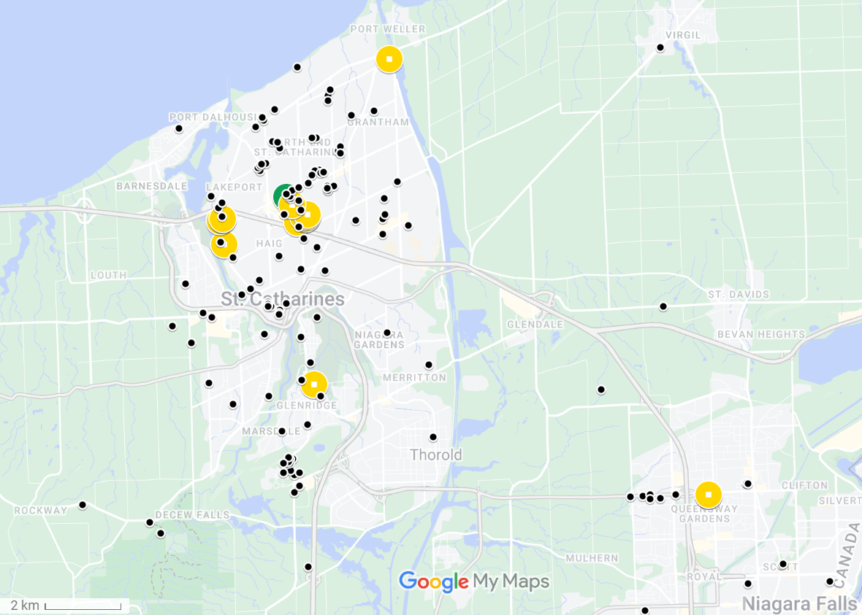

Figure 1: Map of observations from Crowkemon Go and sampling locations. The black dots represent observations collected from Crowkemon Go, and the circular icons are sampling locations. The single recurrent site used is in green. Opportunistic sampling sites are in yellow. Focal area was limited to the St. Catharines & Niagara region.

and visibly dropped 30g of Cheez-Its, then returned to the camera. If crows were on-site, recording would start immediately, whereas if the crows were absent, a crow-caller would be used for 20 minutes (5s. call per min, 5 mins on, 5 mins off for 20 minutes or until crows appear) to attract them. We began recording when crows arrived and recorded up to a maximum of 20 minutes. The recording was stopped if the crows vacated the area for longer than 5 minutes and we remained in the area for 10 minutes post-departure in case the crows returned. If the crows returned within 5 minutes, we would continue the trial. For opportunistic sampling, we looked for crows using Crowkemon Go as a guide. If we found crows that were already foraging, we would set up in the same manner as for recurrent sampling and did not bait the site. Conversely, if the crows were not already foraging, we would bait the site as we did for recurrent sampling.

The presence of a sentinel, whether heard or seen, was announced verbally by the observer during the recording. For each location, we classified the type of environment using St. Catharines municipal zoning maps, later generalized as either “commercial” or “green” (Table S1). Disturbance frequency was calculated by dividing the number of disturbances by the duration of the recording. We identified disturbances as anything passing within 5m of the crows’ foraging area, including vehicles, pedestrians, domestic and wild animals. Group size was binned into two categories: small (4) and large (4).

Video Analysis

For video analyses, we used the Behavioral Observation Research Interactive Software (BORIS v.8.9.4) [2]. We classified behaviours as either “foraging” or “alert”. “Alert” behaviour was defined as an upright posture where the individual is scanning its surroundings, and “foraging” was when the individual was looking downward and unable to effectively scan their surroundings while pecking at or looking for food on the ground (Table S2). We recorded the duration of bouts of each behaviour longer than 0.01s. Movement behaviour was recorded, but since not all bouts of movement were recorded in their entirety, “moving” behaviour was excluded from these analyses. We then calculated the proportion of time spent performing each behaviour. An individual could have two observations if sentinel presence changed, as bouts were recorded separately for if a sentinel was present or not.

We also recorded the number of pecks (handling food with their beaks for the purpose of eating it) to quantify foraging effort. The peck rate (per min) was calculated for every individual by dividing the total number of pecks at food performed by the total duration of “foraging” behaviour. The peck rate of individuals that spent no time foraging could not be calculated and were therefore excluded from peck rate analysis.

Statistical Analysis

All statistical analyses were performed in the R environment (v.4.2.2; R Core Team 2022) [3]. We first ran separate chi-squared tests to determine if the generalized environment, the group size, or the disturbance frequency affected the likelihood of sentinel presence. To determine the effects of generalized environment and sentinel presence on the proportion of time allocated to each behaviour (alert or foraging), we used the “lm” function in the R Stats package [3] to fit a linear model using behaviour type, sentinel presence, and generalized environment as predictors.

To determine the effects of generalized environment and the presence of a sentinel on the duration of bouts of all behaviours, we used the function “rlmer” from the “robustlmm” package [4] to fit a robust linear mixed model to the log-transformed duration of bouts with behaviour type, sentinel presence, generalized environment, group size, and bait presence as fixed factors, the disturbance frequency (number of disturbances per min.) as a fixed effect and the individual ID as a random effect. We then fitted post-hoc robust linear mixed models on each behaviour to determine the effects of sentinel presence and generalized environment on each behaviour. The duration of behavioural bouts was log-transformed to normalize the distribution.

To determine the effects of sentinel presence and generalized environment on peck rate, we used the function “rlmer” from the “robustlmm” package [4] to fit a robust linear mixed model to the peck rate of foragers using sentinel presence, generalized environment, group size, and bait presence as fixed factors, the disturbance frequency (per min) as a fixed effect, and the individual ID as a random effect.

Finally, we counted the number of transitions from each behaviour to determine the effects of sentinel presence and generalized environment on the frequency of each transition type. Using the “glmer” function from the “lme4” package [5], we fitted a generalized linear mixed model using a Poisson distribution to the number of occurrences of each transition. Sentinel presence, generalized environment, and bait presence were fixed factors, the disturbance frequency (per min) was used as a fixed effect, and the total number of transitions performed by the individual was used as a random effect in the model.

Post hoc estimated marginal means tests were performed as appropriate using the “emmeans” function from the “emmeans” package [6]. P-values were corrected using the “fdr” method, and the results were averaged over the unused categorical factors.

Results

Sentinel presence

In summer 2022, we recorded 23 videos of crows foraging and made 13 observations in commercial and 20 observations in green areas. Since sentinel presence changed in 8 videos, we made 19 observations with a sentinel present and 14 observations without a sentinel for a total of 33 observations. The generalized environment (χ2 = 0.122, df = 1, p = 0.727; ), group size (χ2 = 0.248, df = 1, p = 0.618; Figure S2), and the disturbance frequency (χ2 = 2.033, df = 2, p = 0.362; Figure S2) did not significantly affect if a sentinel was present or not in our observations.

Proportion of time allocated to each behaviour

We recorded 64 individuals across 23 videos. Since 17 individuals were recorded in both the presence and absence of a sentinel, we calculated the proportion of time allocated to each behaviour for 81 observations. Crows allocated similar proportions of time to foraging and vigilance ( = 0.026, SE = 0.023, t = 1.160, p = 0.248; Figure 2, ), and neither the presence of a sentinel ( = -0.034, SE = 0.023, t = -1.431, p = 0.154; Figure 2, ) or the generalized environment ( = 0.034, SE = 0.023, t = 1.463, p = 0.146; Figure 2, ) had an effect on the proportion of time allocated to either alert or foraging behaviour.

.

Figure 2: Proportion of time allocated to each behaviour by foragers in commercial and green areas

Table 1: Effects of sentinel presence and generalized environment on the proportion of time allocated to each behaviour

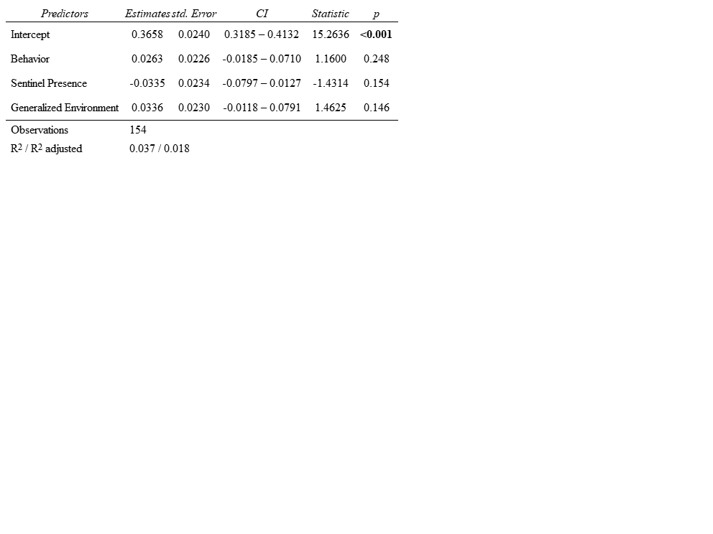

Duration of bouts of all behaviours

In total, 3897 bouts were recorded, of which 2110 bouts were of “alert” behaviour, 1787 bouts were of “foraging” behaviour. The average duration of bouts was of 1.75 seconds. Bouts of alertness and foraging significantly differed ( = -0.256, SE = 0.051, t = -5.002, p = <0.001; Figure 3, Table 2), with bouts of alertness significantly (1.64 seconds) shorter than bouts of foraging (1.88 seconds). Sentinel presence significantly increased the duration of bouts of all behaviours( = 0.197, SE = 0.072, t = 2.741, p = 0.006; Figure 3, Table 2). Green areas saw significantly longer bouts of all behaviours than commercial areas ( = 0.353, SE = 0.087, t = 4.048, p = <0.001; Figure 3, Table 2). Disturbance frequency had a significant effect on the duration of all bouts ( = -0.088, SE = 0.030, t = -2.975, p = 0.003; Figure S3, Table 2), with bout duration decreasing as disturbance frequency increased. We found a significant interaction between generalized environment and sentinel presence ( = -0.252, SE = 0.088, t = -2.863, p = 0.004; Figure 3, Table 2), and between behaviour type and generalized environment ( = -0.202, SE = 0.054, t = -3.769, p = <0.001; Figure 3, Table 2).

Duration of bouts of “foraging” behaviour

To determine if the generalized environment and sentinel presence affected the duration of bouts of foraging and alert behaviour differently, we fit separate linear mixed models for each type of behaviour bout. Sentinel presence had no significant effect on the duration of bouts of foraging behaviour ( = 0.092, SE = 0.072, t = 1.280, p = 0.201; Figure 3, Table 2). Generalized environment had a significant effect on the duration of bouts of foraging behaviour, with longer bouts in green areas ( = 0.383, SE = 0.078, t = 4.919, p = <0.001; Figure 3, Table 2). Larger groups had significantly longer bouts of foraging behaviour ( = -0.152, SE = 0.068, t = -2.221,

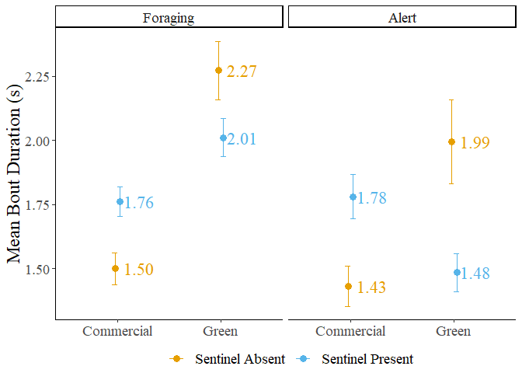

Figure 3: Mean bout duration of foragers in commercial and green areas. The error bars represent the standard error.

Table 2: Results of the linear mixed models fit to the mean bout duration

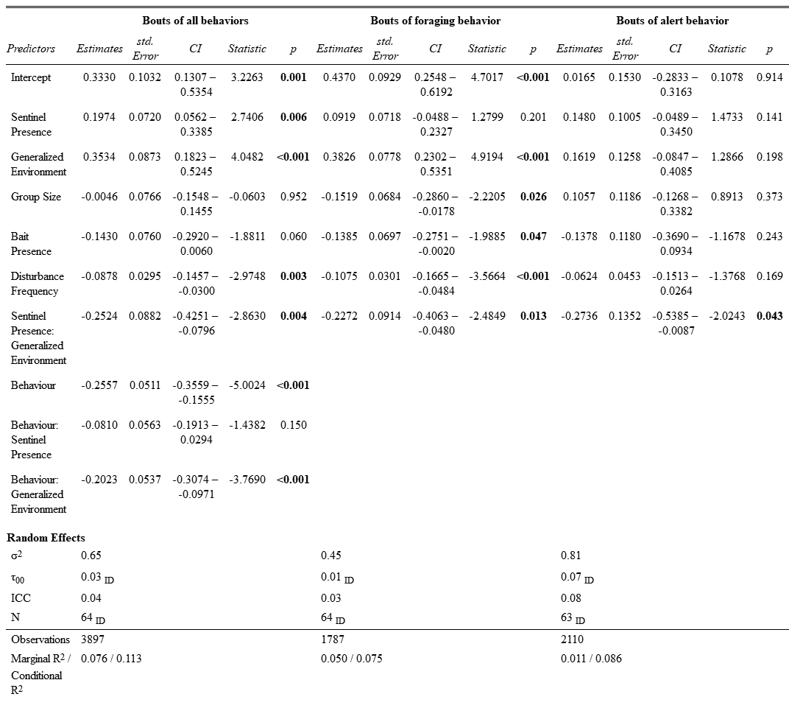

p = 0.026; Figure 4, Table 2). The presence of bait significantly decreased the duration of foraging bouts ( = -0.139, SE = 0.070, t = -1.989, p = 0.047; Figure S4, Table 2). Increasing disturbance frequency significantly decreased the duration of foraging bouts ( = -0.108, SE = 0.030, t = -3.566, p = <0.001; Figure 5, Table 2). We found a significant interaction between generalized environment and sentinel presence ( = -0.227, SE = 0.091, t = -2.485, p = 0.013; Figure 3, Table 2). Post hoc tests revealed significant differences in the duration of bouts of foraging behaviour. In the absence of a sentinel, foragers in green areas had significantly longer bouts of foraging behaviour than in commercial areas ( = -0.383, SE = 0.078, z-ratio = -4.919, p < 0.001; Table S3). In the presence of a sentinel, foragers in green areas also had significantly longer bouts of foraging behaviour than in commercial areas ( = -0.156, SE = 0.067, z-ratio = -2.337, p = 0.029; Table S3). In green areas, foragers in the presence of a sentinel had marginally shorter bouts of foraging behaviour than in the absence of a sentinel ( = 0.135, SE = 0.068, z-ratio = 1.977, p = 0.058; Table S3).

Duration of bouts of “alert” behaviour

Sentinel behaviour, generalized environment, group size, bait presence and disturbance frequency had no significant effect on the duration of bouts of alert behaviour (p < 0.141; Table 2). We found a significant interaction between sentinel behaviour and generalized environment ( = -0.274, SE = 0.135, t = -2.024, p = 0.043; Figure 3, Table 2). Post hoc pairwise t-tests revealed no significant differences in the duration of bouts of alert behaviour.

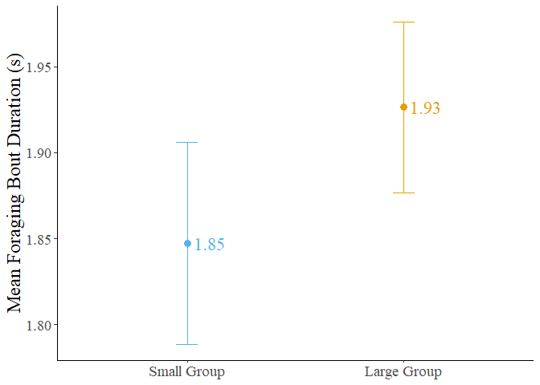

Figure 4: Mean foraging bout duration of crows in small and large groups. Error bars represent the standard error.

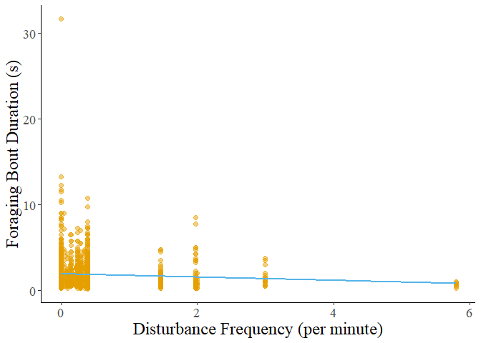

Figure 5: Foraging bout duration decreasing with increasing disturbance frequency.

Foraging rate

We calculated the peck rate (per min.) for 81 observations. Two observations were removed as the individuals did not perform any foraging behaviour. Neither the presence of a sentinel, the generalized environment, or group size had a significant effect on the peck rate of foragers (p > 0.233; Figure 6, Table 3). The presence of bait significantly increased the peck rate of foragers ( = 13.990, t = 2.231, p = 0.020; Figure S5, Table 3). Peck rate increased significantly with disturbance frequency ( = 5.290, t = 2.312, p = 0.021; Figure 7, Table 3). We found a significant interaction between generalized environment and disturbance frequency ( = 16.150, t = 3.046, p = 0.002; Figure 7, Table 3).

Transition analysis

The number of transitions from foraging to alert behaviour was significantly higher in green areas (IRR = 0.421, SE = 0.157, z = -1.355, p = 0.020; Figure 8, Table 4), and in areas with frequent disturbances (IRR = 0.728, SE = 0.109, z = -2.130, p = 0.033; Figure 9, Table 4). We found a significant interaction between generalized environment and sentinel presence (IRR = 5.021, SE = 2.457, z = 3.298, p = 0.001; Figure 8, Table 4). The number of transitions from foraging to pecking was significantly higher in the presence of bait (IRR = 1.710, SE = 0.384, z = 2.386, p = 0.017; Figure S6, Table 4). Sentinel presence, generalized environment, disturbance frequency, or the interaction between sentinel presence and generalized environment did not affect the number of transitions from foraging to pecking (p-value > 0.385; Table 4). The number of transitions from pecking to alert behaviour was also significantly higher in the presence of bait (IRR = 2.204, SE = 0.538, z = 3.238, p = 0.001; Figure S6, Table 4). Sentinel presence, generalized environment, disturbance frequency, or the interaction between sentinel presence and generalized environment did not affect the number of transitions from pecking to alert behaviour

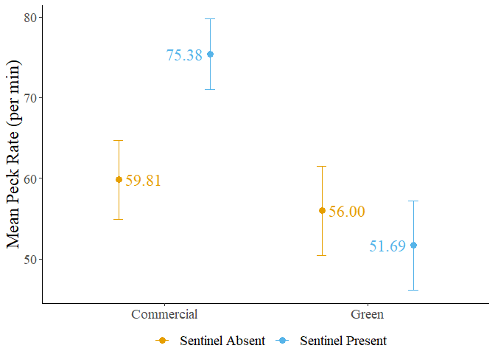

Figure 6: Mean peck rate of foragers in commercial and green areas. Error bars represent the standard error.

Table 3: Result of the linear mixed model fit to peck rate

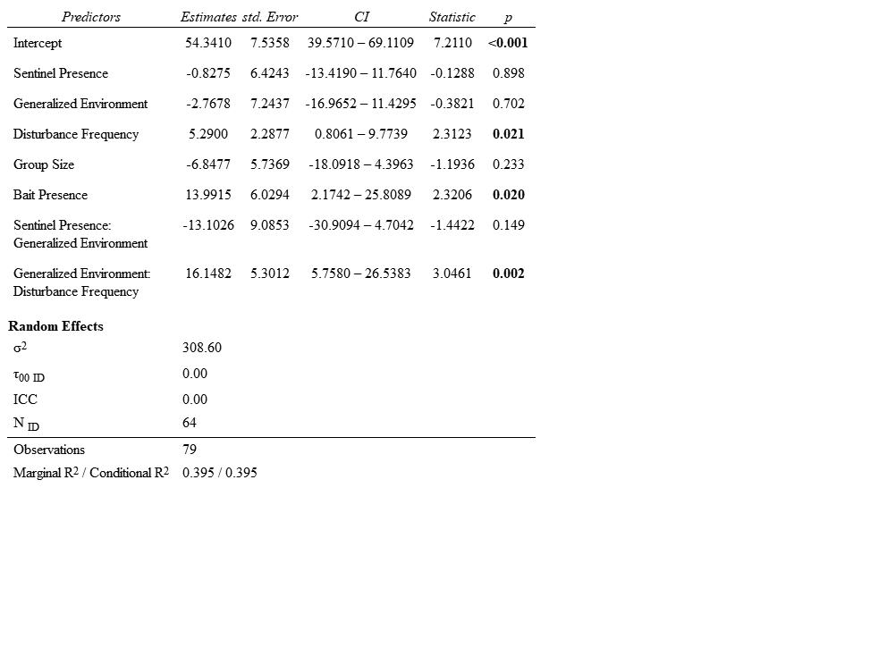

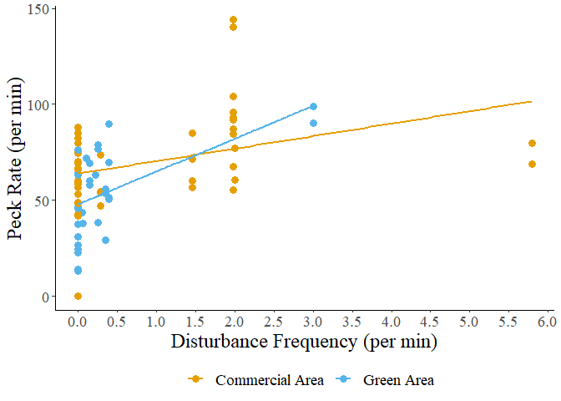

Figure 7: Peck rate in relation to disturbance frequency.

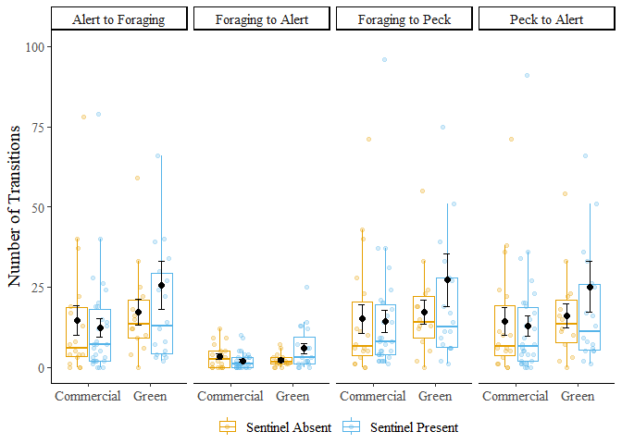

Figure 8: Number of transitions performed by foragers in commercial and green areas. Error bars represent the standard error. Three outliers (Nb.>100) omitted from figure.

Table 4: Results of generalized linear mixed model fit to the number of transitions performed by foragers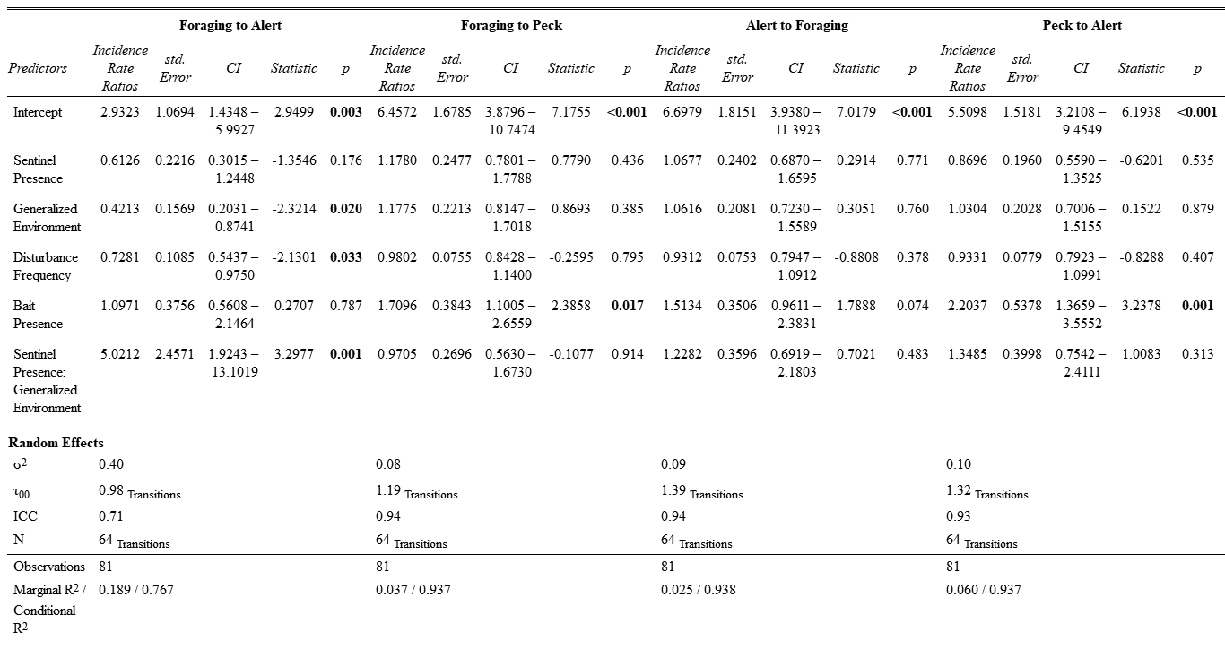

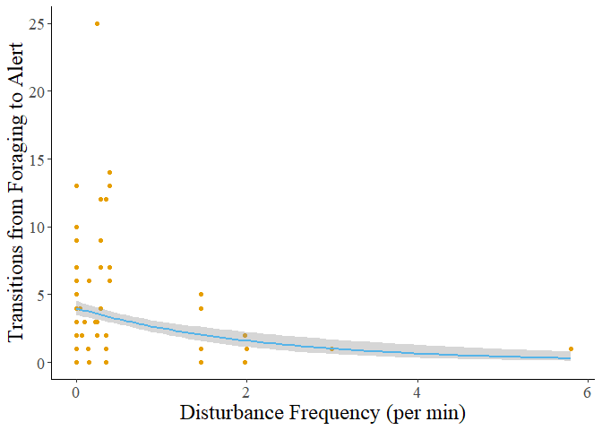

Figure 9: The number of transitions from foraging to alert behaviour decreases as disturbance frequency increases. The grey shadow represents the standard error of the curve.

(p-value > 0.235; Table 4). The number of transitions from alert to foraging behaviour were not significantly affected by any factors, however, bait presence had a marginally insignificant effect (IRR = 1.513, SE = 0.351, z = 1.789, p = 0.074; Figure S6, Table 4).

Post hoc testing on the number of transitions from foraging to alert behaviour revealed that in green areas, individuals performed more transitions from foraging to alert when in the presence of a sentinel ( = -1.124, SE = 0.346, z-ratio = -3.250, p = 0.007; Table S4). Foragers in the presence of a sentinel performed marginally more transitions from foraging to alert in green areas than in commercial areas ( = -0.749, SE = 0.364, z-ratio = -2.062, p = 0.079; Table S4). However, foragers in the absence of a sentinel performed marginally more transitions from foraging to alert behaviour in commercial areas than in green areas ( = 0.864, SE = 0.372, z-ratio = 2.321, p = 0.061; Table S4).

Discussion

Our study sought to investigate how the presence of a sentinel and the generalized environment affected the behavior of foraging American crows. We initially hypothesized that the presence of a sentinel would decrease the individual vigilance of crow foragers, and that green areas would likewise decrease individual vigilance due to reduced ambient noise and longer lines of sight. We also expected the likelihood of a sentinel being present to increase in commercial and frequently disturbed areas where the benefits of sentinel coverage would be most beneficial to the foragers. Sentinel presence had no other significant effects on the behaviour of foragers apart from significantly increasing the duration of all behaviours. Moreover, neither the generalized environment, disturbance frequency, nor group size significantly affected the likelihood of a sentinel being present. This unexpected result suggests that sentinel crows could decide to perform sentinel behavior based more on selfish needs rather than the benefits imparted to the foragers. We found that the generalized environment had a significant effect on forager behavior, with green areas leading to longer bouts of foraging behavior and more transitions from the vulnerable to the alert state. This suggests that crows could perceive green areas as less safe, possibly because they need to spend more time being vulnerable. Overall, the study's findings do not fully support the initial hypotheses and suggest that sentinel behavior and forager behavior in crows could be influenced by complex interactions between individual factors and forager’s perception of the safety of their environment.

Sentinel behaviour

Our results contrast with previous studies that found that the presence of a sentinel led to a decrease in alert behavior [7,8]. For example, pied babblers, *Turdoides bicolor*, increased the proportion of time spent foraging after the start of a sentinel bout and had increased biomass intake. Sentinel behavior can be more selfish in nature, primarily benefiting the sentinel itself rather than being an altruistic strategy benefiting the group at the expense of the sentinel. Bedneckoff's state-dependent model states that individuals make decisions based on their own energetic needs and the benefits they receive [9]. An individual with sufficient energetic reserves could decide to perform sentinel behaviour as a safer option if the alternative is foraging without a sentinel. In urban areas, where high-calorie food patches are bountiful, individuals could be forgoing foraging to act as sentinels for their own safety rather than to provide benefits to the other foraging group-members. These sentinels only come down when they are below a critical energetic threshold past which performing sentinel behaviour is unfavourable only to be replaced by another individual with sufficient energetic reserves [9,10]. The benefits of sentinel behavior can be more subtle or indirect, such as providing a greater sense of security that allows foragers to focus more on foraging without actively reducing their vigilance. The proportion of time allocated to alert behaviour could also be used to scan for foraging patches and other foragers, explaining the absence of effects of sentinel presence on the proportion of time spent being alert. Foragers could also be benefitting from sentinel presence by increasing the distance between foragers, permitting the group to forage over a greater surface area while compensating for the increased predation risk from foraging further apart [7]. Sentinel behaviour could therefore compensate for riskier group-foraging strategies, not only individual changes in behaviour. The relationship between sentinels and foragers is more complex than it appears, reinforcing the importance of considering individual differences and motivations when studying social behaviors.

Generalized Environment

We found that the generalized environment had significant effects on forager behaviour, particularly in terms of the duration of bouts of foraging behavior and the number of transitions from the vulnerable to the alert state. In green areas, crows exhibited longer bouts of foraging behavior, suggesting that they spent more time actively searching for food. Likewise, an increase in the number of transitions from the vulnerable state to the alert state was observed in green areas, suggesting that crows were more vigilant and alert to potential threats, possibly due to the perceived higher predation risk compared to commercial areas.

Green areas, such as parks, offer longer lines of sight and less ambient noise which makes the sentinel more effective [11] but could also be benefitting urban raptors. Urban red-tailed hawk populations are on the rise and the core of their home ranges were associated with large green areas [12]. Foraging in green areas could therefore be riskier than initially hypothesized, explaining the individual need to maintain vigilance. We observed foraging crows abandon sites when disturbed by raptors but only temporarily flee when disturbed by vehicles. Crows foraging in the street will change lanes to avoid oncoming vehicular traffic [13], suggesting that the type of disturbances in each environment could change how risky an environment is to forage on.

The increased duration of foraging bouts in green areas could suggest that they need to spend more time actively searching for and consuming food. We observed shorter bouts of foraging behavior but a higher peck rate in commercial areas. In green areas, food can be more dispersed, require more time to locate, and could be obscured by vegetation. Comparatively, food scraps and litter in commercial areas which are considerably easier to forage on when on impermeable surfaces. Moreover, anthropogenic foods have a greater caloric content than non-anthropogenic foods, making them easier to find and more satiating than other food sources, likely playing a role in the shift in their foraging preferences for anthropogenic foods [14,15].

We found a significant interaction between sentinel presence and generalized environment on the behaviour of crow foragers. The number of transitions from a vulnerable to alert state was highest in green areas and in the presence (Figure 8). We found a significant interaction between sentinel presence and generalized environment on the duration of bouts of foraging and alert behaviour. Bouts were longest in green areas and in the absence of a sentinel, and shortest in commercial areas and in the absence of a sentinel (Figure 3). Foragers could be using the indirect benefits provided by sentinel behaviour differently based on their individual and group needs. In green areas foragers could be relying more on the sentinel, foraging further apart and not coordinating vigilance with other group-members. We observed this as shorter but more numerous bouts of alert behaviour between longer foraging bouts. In contrast, foragers in the absence of a sentinel could be relying more heavily on social foraging behaviour between foragers on the ground, with longer bouts of alert behaviour to increase the likelihood of at least one crow being alert. Whether crows have ground-level coordination of vigilance is an interesting topic for future research.

In commercial areas, crows in the absence of a sentinel could be foraging in an all-or-nothing manner, devoting as little time as possible to each behaviour resulting in shorter bouts of both foraging and alert behaviour, with a duration similar to the duration of bouts of alert behaviour in green areas and in the presence of a sentinel. In comparison, foragers in the presence of a sentinel and in commercial areas saw approximately equal durations of bouts of foraging and alert behaviour. The increased duration of bouts of alert behaviour could be due to the increased frequency and velocity of disturbances, paired with the increased ambient noise, making the sentinel’s behaviour less effective. The duration of bouts of foraging behaviour was likewise increased but not as much as in green spaces, further supporting the hypothesis that foraging in green spaces requires more handling time than in commercial areas. By changing the duration and frequency of bouts to best take advantage of the benefits provided by the sentinel, crows maximize their foraging success and minimize the risk of predation in different foraging environments. American crows continue to demonstrate a behavioural adaptability that is likely crucial for their success in urban cityscapes, and this adaptability must also include the use of social foraging behaviours.

Disturbances

Higher disturbance frequency led to a decrease in the duration of bouts of all behaviors, particularly foraging. American crows decreased their time foraging to minimize their exposure to perceived threats. Areas with higher disturbance frequencies typically had a greater frequency of vehicular disturbances, which American crows could be more tolerant to. As a result and consistent with the risk allocation hypothesis [16], crows will continue to forage between disturbances, but will also increase foraging rate when under high chronic risk of predation. Peck rate did significantly increase with disturbance frequency, and we found a significant interaction between disturbance frequency and generalized environment on peck rate. In response to increasing disturbance frequency, foragers in green areas increased their peck rate more than foragers in commercial areas, further supporting the hypothesis that the type of disturbance as well as the frequency affects the foraging behaviour of urban crows. Higher disturbance frequency was also associated with a significant decrease in the number of transitions from foraging to alert behaviour, from which we can infer that crows will attempt to spend as little time as possible under threat while maximizing time spent foraging. Crows could then be foraging as quickly as possible while maintaining minimal vigilance and flying away as soon as a threat is detected.

Baited sites

The presence of bait, which can be considered a proxy for human-generated litter in the environment, increased the peck rate and decreased the duration of foraging bouts. This suggests that foraging on bait or litter is more efficient and safer for crows, requiring less time and effort compared to foraging on natural food sources. This observation could explain why a shift in preference for anthropogenic foods is observed in American crows and potentially other urbanized species [14,15]. American crows are increasingly found in North American cities and the increasing abundance of crows in cities is believed to be driven by the increased presence of highly caloric anthropogenic foods [15].

Group Size

As group size increased, the duration of bouts of foraging behaviour increased but was not associated with a decrease in duration of bouts of alert behaviour. The proportion of time allocated to either behaviour was also unchanged by the size of the group. This finding is surprising, as previous studies suggest that larger group sizes should decrease individual vigilance while increasing foraging efficiency [17–20], yet the effect of group size was only observed in the duration of bouts of foraging behaviour. Bouts of alert behaviour could have a minimal duration to effectively monitor the surrounding environment for sources of threat. Alternatively, foraging crows could be maintaining vigilance due to increased competition for resources in larger groups. Instead of only looking out for sources of threat, forager could be looking at the behaviour of other group-members in case they found a better patch to forage on.

Future directions and improvements

Our study has several limitations that should be acknowledged. Our sample size could have limited the ability to detect significant effects. As such, caution should be exercised when interpreting the results, and further studies with larger sample sizes are required to make conclusive statements. Future studies should make use of long-term video recorders in areas where crows forage across a wider breadth of urbanization. Additionally, the study focused on the population of crows in St. Catharines Ontario, which could limit the generalizability of our results to other populations or environments. Factors such as local food availability, the number and area of green spaces, and predator presence can vary widely between cities, and these factors can affect the behaviour of murders of foraging crows. Therefore, the findings of our study could differ from those of a similar study performed in a different city, but also within the city. Crows can aggregate in many other areas besides green and commercial areas, and future research could be conducted on the effects of urban microcosms on the social foraging of crows.

Conclusion

Our study investigated the effects of sentinel behavior and the generalized environment on the behavior of foraging crows in urban environments. Contrary to expectations, sentinel presence did not have a significant effect on forager behavior. This suggests that sentinel decision-making could be more influenced by individual needs rather than group benefits, aligning with Bednekoff's state-dependent model. The generalized environment, however, had a significant impact on forager behavior. Crows in green areas exhibited longer bouts of foraging behavior and more transitions from the vulnerable to the alert state compared to those in commercial areas. This indicates that environmental factors such as resource distribution and predation risk play a crucial role in shaping forager behavior. Disturbance frequency, bait presence, and group size also influenced forager behavior. Higher disturbance frequency led to shorter bouts of behavior but increased peck rate, indicating a trade-off between vigilance and foraging efficiency. Bait presence increased peck rate and decreased foraging time, suggesting that foraging on anthropogenic food sources could be more effective for crows.

These findings have several implications for understanding crow behavior. They suggest that crows can adapt their behavior based on environmental conditions and individual needs. The lack of significant effects of sentinel behavior points towards the complexity of social behavior in crows and the importance of considering individual variation in decision-making. Overall, the study provides valuable insights into the factors influencing crow behavior in urban environments and highlights the need for further research to fully understand these complex behaviors.

References

1. Møller AP. 1990 Changes in the size of avian breeding territories in relation to the nesting cycle. *Anim. Behav.* **40**, 1070–1079. (doi:10.1016/S0003-3472(05)80173-3)

2. Friard O, Gamba M. 2016 BORIS: a free, versatile open-source event-logging software for video/audio coding and live observations. *Methods Ecol. Evol.* **7**, 1325–1330. (doi:10.1111/2041-210X.12584)

3. R Core Team. 2022 R: the R project for statistical computing.

4. Koller M. 2016 Robustlmm: an R package for robust estimation of linear mixed-effects models. *J. Stat. Softw.* **75**, 1–24. (doi:10.18637/jss.v075.i06)

5. Bates D, Mächler M, Bolker B, Walker S. 2015 Fitting linear mixed-effects models using lme4. *J. Stat. Softw.* **67**, 1–48. (doi:10.18637/jss.v067.i01)

6. Lenth RW. 2023 Emmeans: estimated marginal means, aka least-squares means.

7. Hollén LI, Bell MBV, Radford AN. 2008 Cooperative sentinel calling? Foragers gain increased biomass intake. *Curr. Biol.* **18**, 576–579. (doi:10.1016/j.cub.2008.02.078)

8. Ridley AR, Wiley EM, Thompson AM. 2014 The ecological benefits of interceptive eavesdropping. *Funct. Ecol.* **28**, 197–205. (doi:10.1111/1365-2435.12153)

9. Bednekoff PA. 1997 Mutualism among safe, selfish sentinels: a dynamic game. *Am. Nat.* **150**, 373–392. (doi:10.1086/286070)

10. Bednekoff PA. 2001 Coordination of safe, selfish sentinels based on mutual benefits. *Ann. Zool. Fenn.* **38**, 5–14.

11. Hollén LI, Bell MBV, Wade HM, Rose R, Russell A, Niven F, Ridley AR, Radford AN. 2011 Ecological conditions influence sentinel decisions. *Anim. Behav.* **82**, 1435–1441. (doi:10.1016/j.anbehav.2011.09.028)

12. Morrison JL, Gottlieb IGW, Pias KE. 2016 Spatial distribution and the value of green spaces for urban red-tailed hawks. *Urban Ecosyst.* **19**, 1373–1388. (doi:10.1007/s11252-016-0554-0)

13. Mukherjee S, Ray-Mukherjee J, Sarabia R. 2013 Behaviour of American Crows (Corvus brachyrhynchos) when encountering an oncoming vehicle. *Can. Field-Nat.* **127**, 229. (doi:10.22621/cfn.v127i3.1488)

14. Marzluff JM, Neatherlin E. 2006 Corvid response to human settlements and campgrounds: Causes, consequences, and challenges for conservation. *Biol. Conserv.* **130**, 301–314. (doi:10.1016/j.biocon.2005.12.026)

15. Marzluff JM, McGowan KJ, Donnelly R, Knight RL. 2001 Causes and consequences of expanding American Crow populations. In *Avian Ecology and Conservation in an Urbanizing World* (eds JM Marzluff, R Bowman, R Donnelly), pp. 331–363. Boston, MA: Springer US. (doi:10.1007/978-1-4615-1531-9_16)

16. Lima SL, Bednekoff PA. 1999 Temporal Variation in Danger Drives Antipredator Behavior: The Predation Risk Allocation Hypothesis. *Am. Nat.* **153**, 649–659. (doi:10.1086/303202)

17. Beauchamp G. 2013 *Social predation: how group living benefits predators and prey*. Elsevier.

18. Beauchamp G. 2008 What is the magnitude of the group-size effect on vigilance? *Behav. Ecol.* **19**, 1361–1368. (doi:10.1093/beheco/arn096)

19. Lima SL. 1995 Back to the basics of anti-predatory vigilance: the group-size effect. *Anim. Behav.* **49**, 11–20. (doi:10.1016/0003-3472(95)80149-9)

20. Ward C, Low BS. 1997 Predictors of Vigilance for American Crows Foraging in an Urban Environment. *Wilson Bull.* **109**, 481–489.

Supplemental Material

List of Supplemental Tables

Table S1: Explanation of generalized environment 22

Table S2: Ethogram of behaviours analyzed during foraging events 23

Table S3: Results of post hoc tests on foraging bout duration 27

Table S4: Result of post hoc test performed on the number of transitions from foraging to alert behaviour 31

List of Supplemental Figures

Figure S1: Sentinel presence in commercial and green areas 24

Figure S2: Frequency plots of observations in the presence and absence of a sentinel 25

Figure S3: Decreasing bout duration of all behaviours in response to increasing disturbance frequency 26

Figure S4: Mean bout duration in the presence and absence of bait 28

Figure S5: Mean forager peck rate in the presence and absence of bait 29

Figure S6: Number of transitions performed by foragers in the presence and absence of bait 30

Table S1: Explanation of generalized environment.

|  |  |
| --- | --- |
| Generalized Environment | Zones included |
| Commercial Area | Arterial Commercial, Business Commercial Employment, Community Commercial, Major Commercial |
| Green Area | Major Green Space, Minor Green Space |

Each zone type was identified using the St. Catharines and Niagara zoning maps for each sampling location.

Table S2: Ethogram of behaviours analyzed during foraging events.

|  |  |  |  |
| --- | --- | --- | --- |
| Behaviour | Code | Definition | Illustration |
| Foraging | Head Down | Focal individual is stationary and has its head downwards or in a non-upright position, either pecking or handling food, looking for food, or engaging in other behaviours that make vigilance ineffective (e.g. preening). |  |
| Moving | Moving | Focal individual is moving, either by flying, hopping (leaping), or walking. |  |
| Alert | Head Up | The focal individual is stationary and has its head and body in an upright position. Individuals can have a mobile (scanning) or immobile head but must not be looking downwards. Individuals can be handling food. |  |

*All illustrations are under creative commons license (copyright-free)*

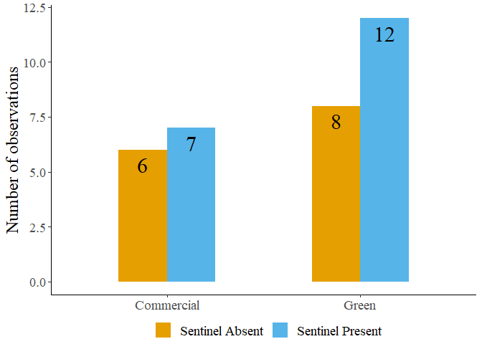

Figure S1: Sentinel presence in commercial and green areas.

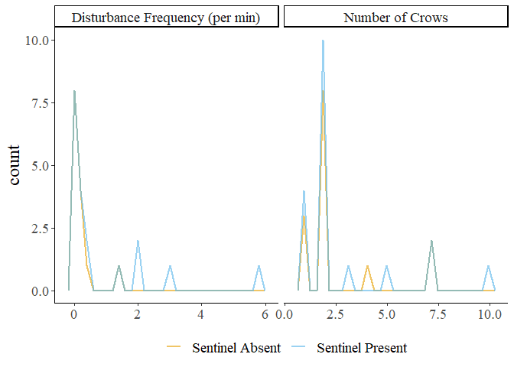

Figure S2: Frequency plots of observations in the presence and absence of a sentinel.

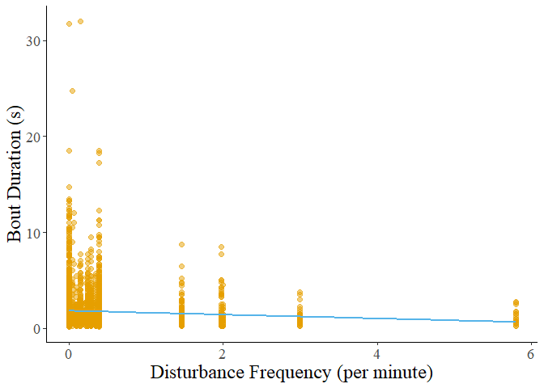

Figure S3: Decreasing bout duration of all behaviours in response to increasing disturbance frequency.

Table S3: Results of post hoc tests on foraging bout duration.

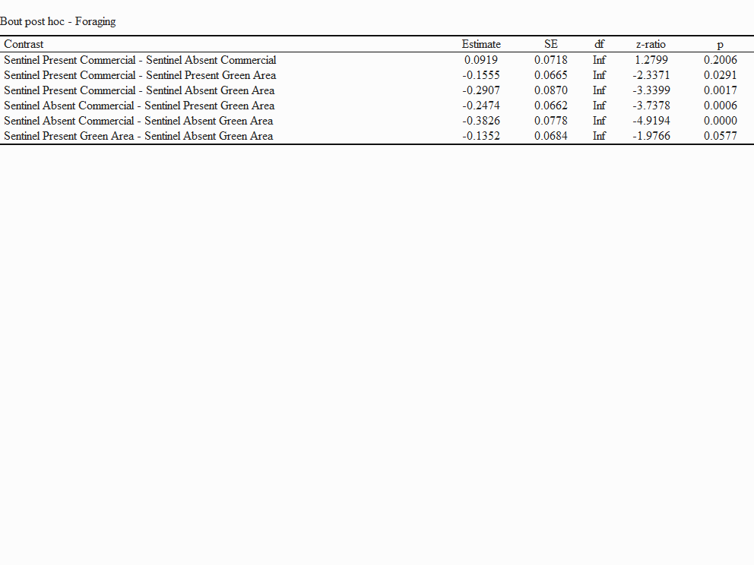

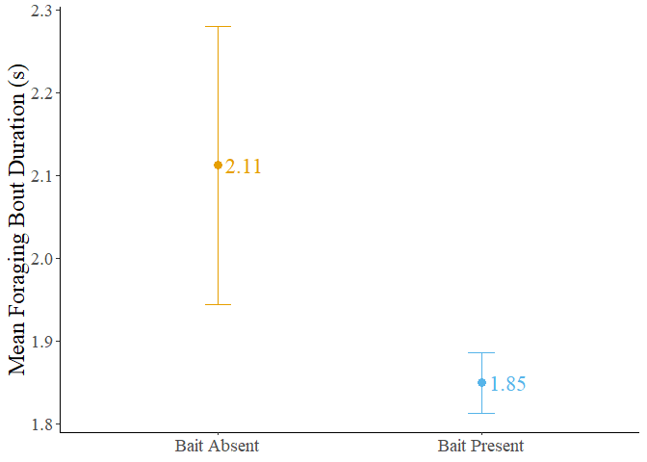

Figure S4: Mean bout duration in the presence and absence of bait. The dots represent the mean value, and the error bars represent the standard error.

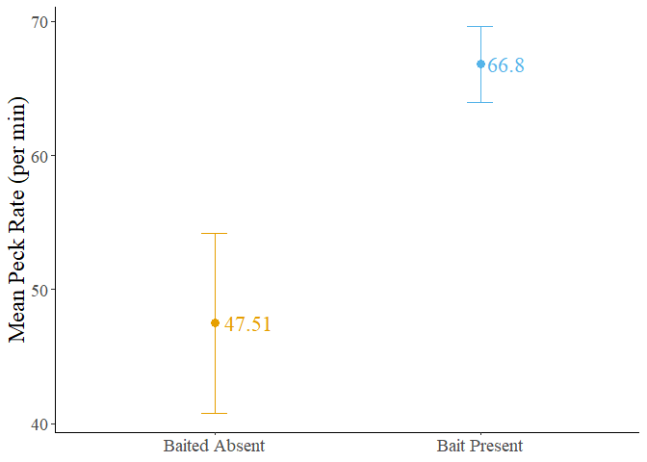

Figure S5: Mean forager peck rate in the presence and absence of bait. The dots represent the mean value, and the error bars represent the standard error.

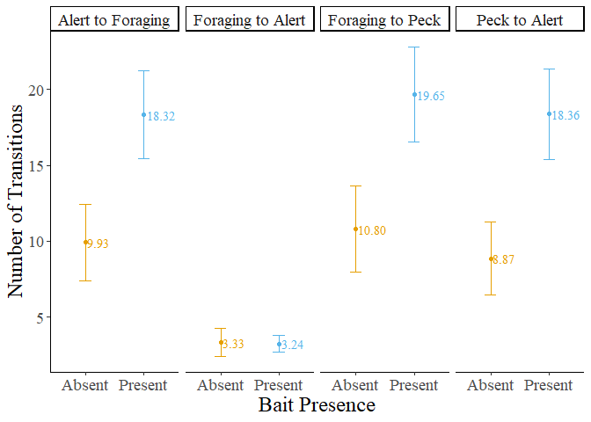

Figure S6: Number of transitions performed by foragers in the presence and absence of bait. The dots represent the mean value, and the error bars represent the standard error.

Table S4: Result of post hoc test performed on the number of transitions from foraging to alert behaviour.

